**Validation Document**

1. **Index.htm**:

No Errors and No Warnings

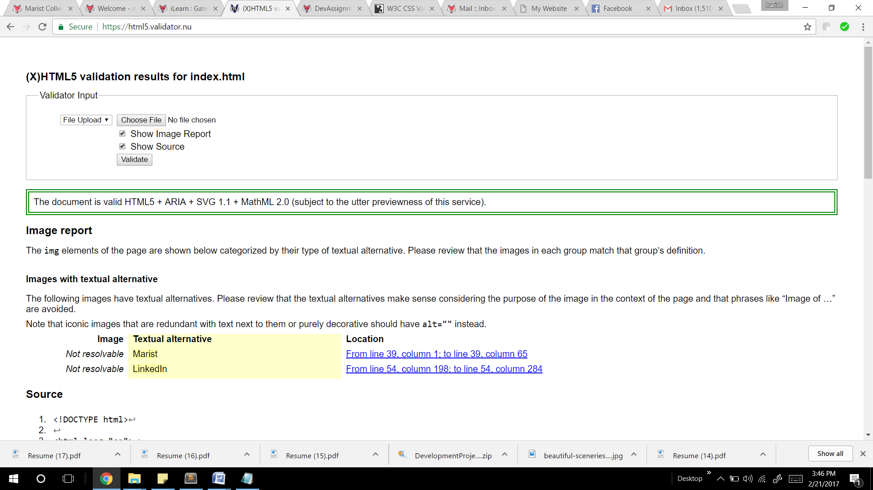

1. **Styles.css:**

No Errors and No Warnings

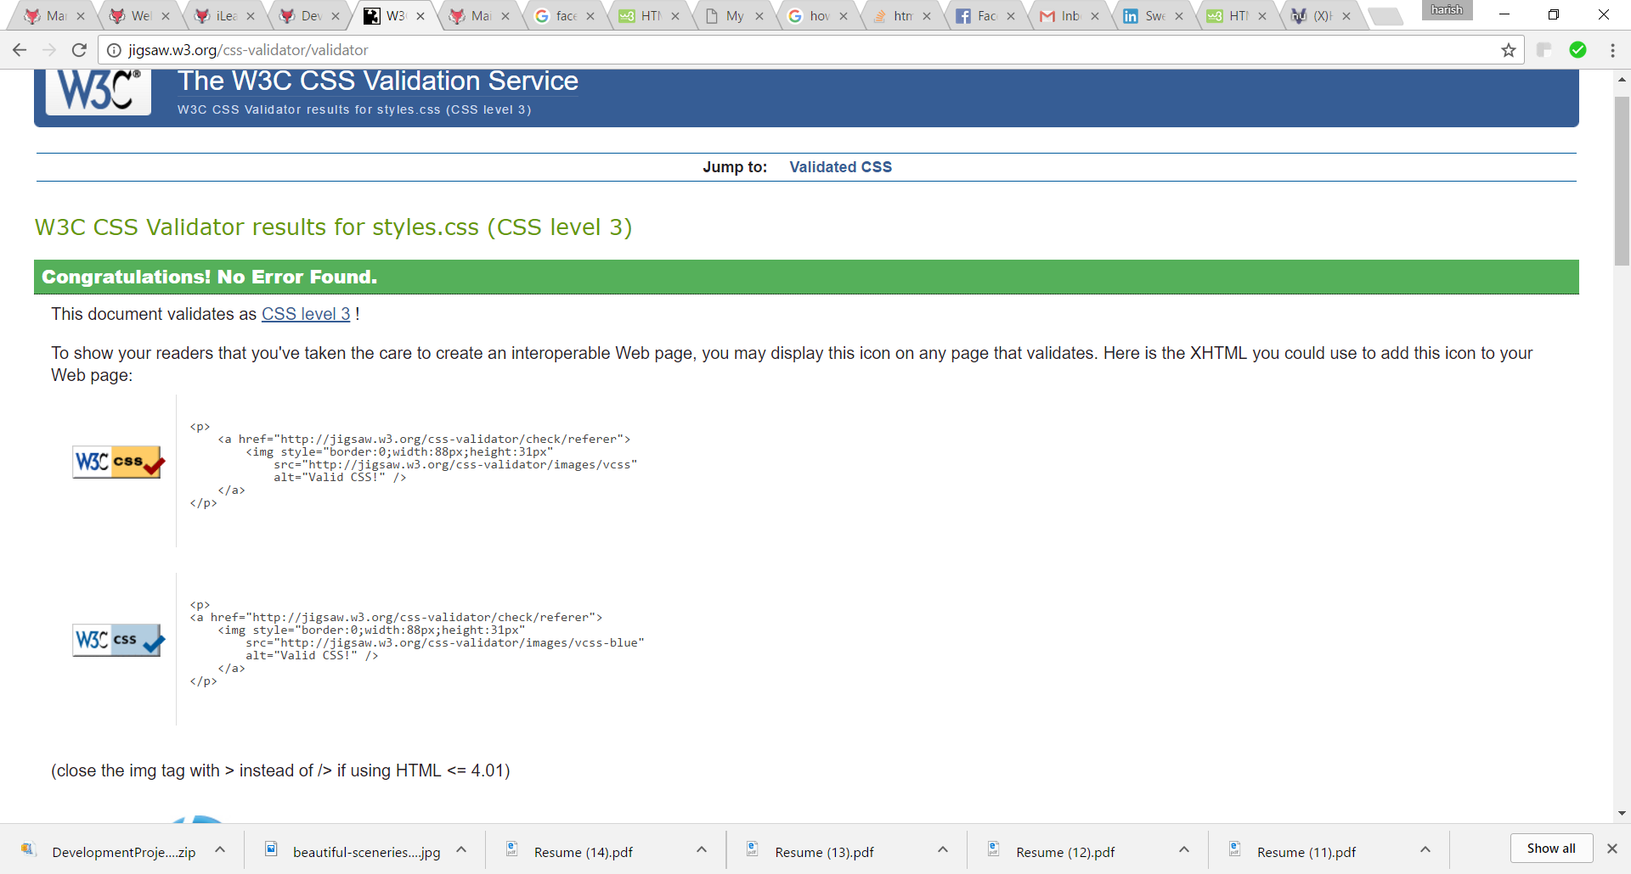

1. **ContactMe:**

No Errors and No Warnings

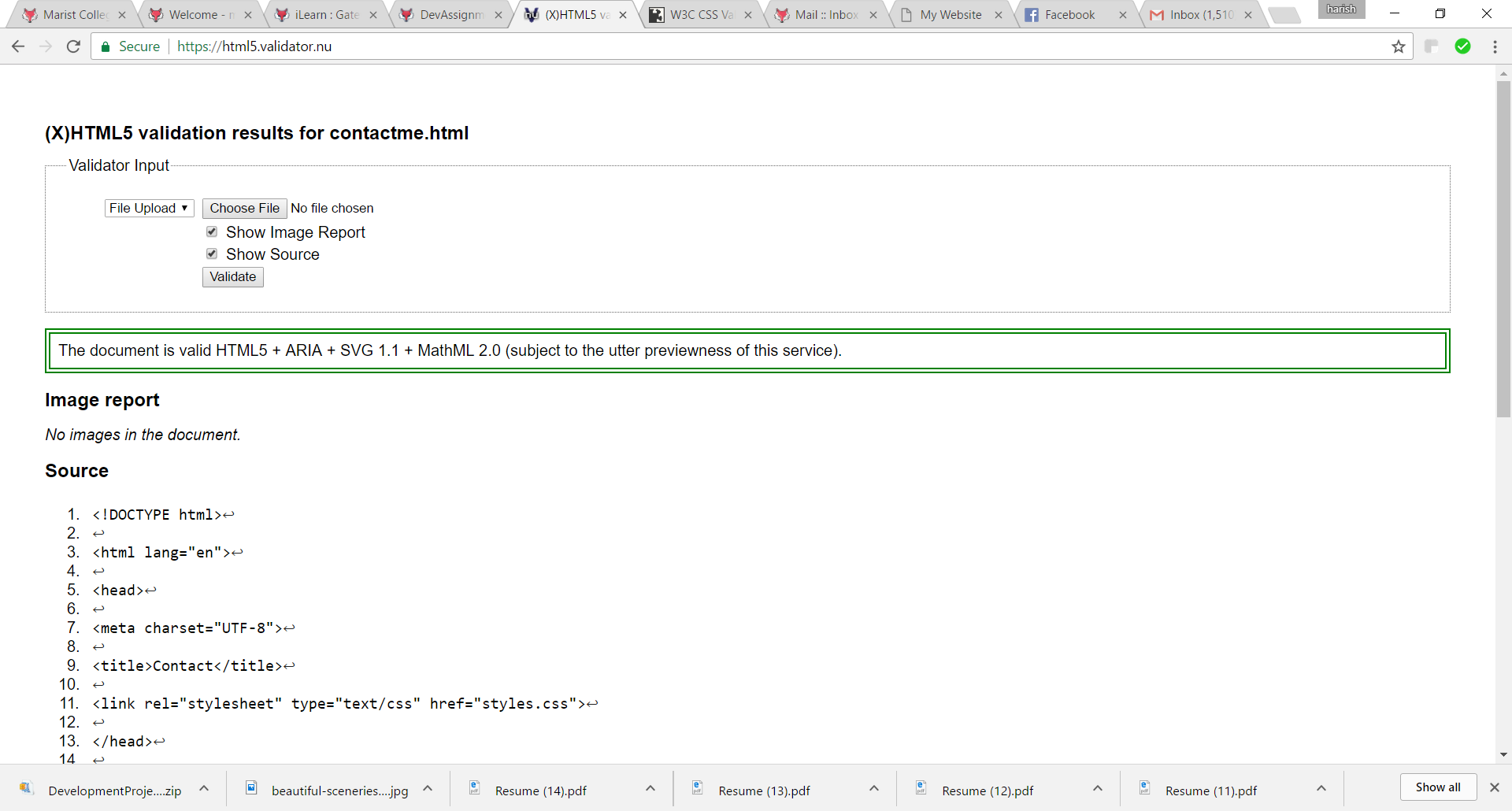

1. **AboutMe:**

No Errors and No Warnings

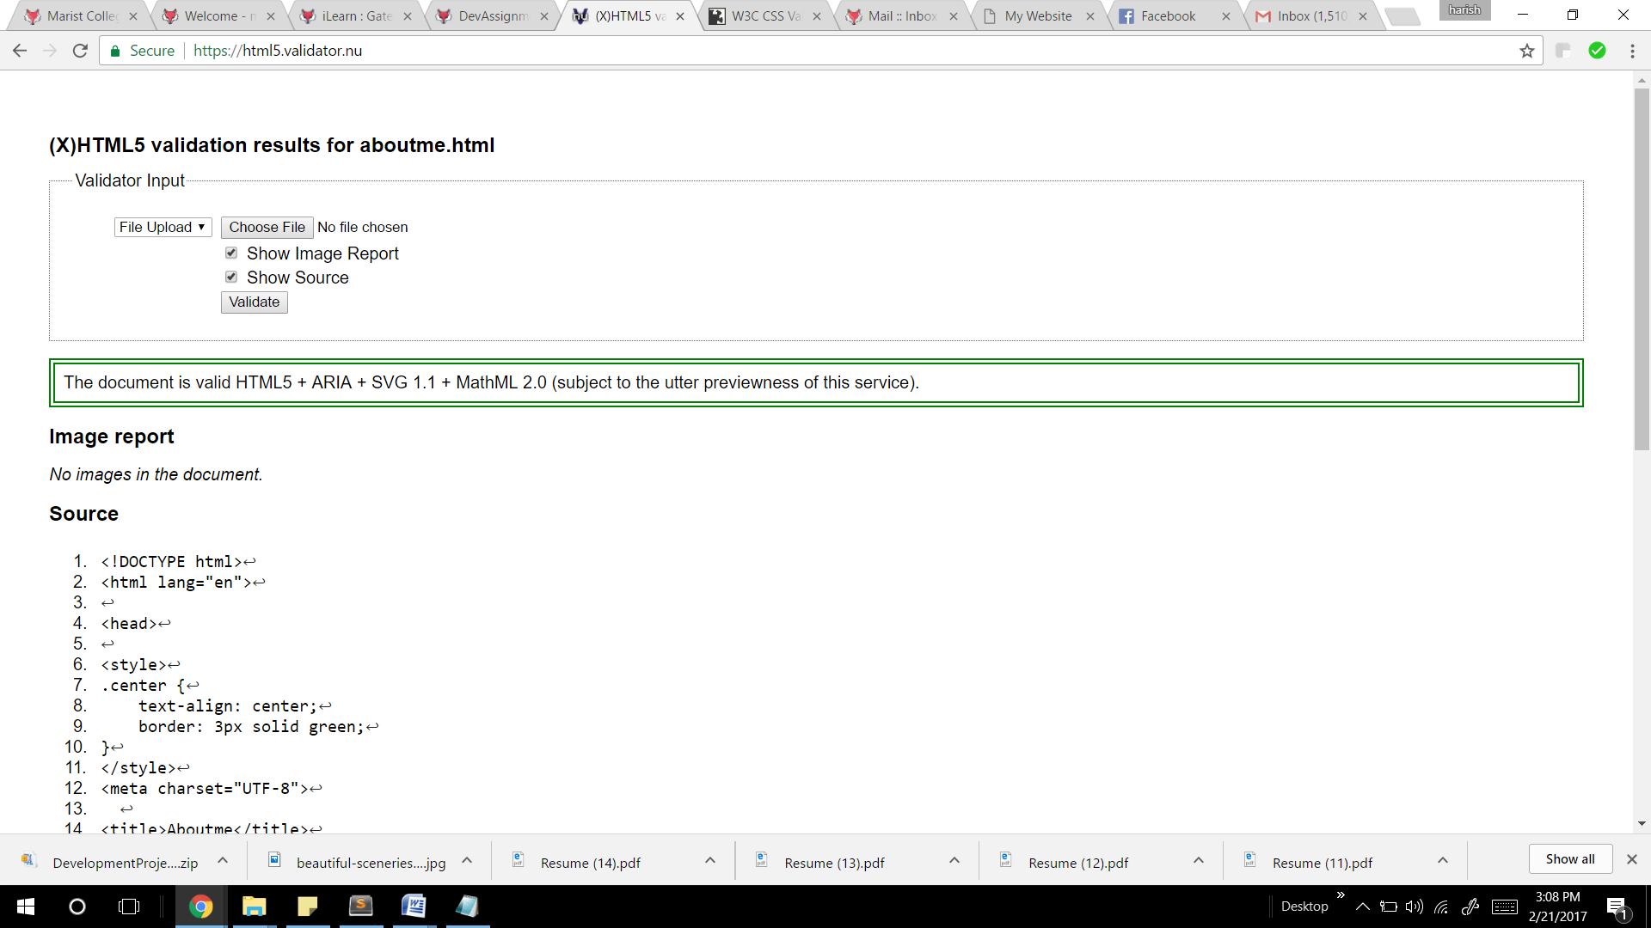

1. **Skills:**

